Lab 3 Fourier Series
By Christopher W. Fingers
Professor Morshed
EE 382 Tuesday/Thursday 3:30 pm - 5:45 Pm
Part 1 Compact Fourier 1
Part B 2
Part 4 Dft/FFt 8
Part 5 FFt 9
Part 7 Filtering 10

Part 1 Compact Fourier
% Define variables and vector
count =1;
y =0;
n = 3;
cn = [ 0.504 .244 .125 .084 .063 .0504 .042 .036];
t= 0:0.001:pi;
% Create while loop to add counted values to y vector
while count ~=n
x = (2/(sqrt(1+16*(count)^2))*cos(2.*count.*t - atan(4*count)));
y = y +x;
count = count+1;
end
% Add A0 value to compact fourier equation
y = cn(1) + cn(1).*y;
hold on
plot(t,y)
xlabel('Time(sec)');
ylabel('Amplitude');
title ('Amplitude vs Time 2, 5 and 7 Harmonics');
y = 0;
n = 6;
count =1;
while count ~=n
x = 2/(sqrt(1+16*(count)^2))*cos(2.*count.*t - atan(4*count));
y = y +x;
count = count+1;
end
y = cn(1) + cn(1).*y;
hold on
plot(t,y)
y =0;
n = 8;
count =1;
while count ~=n
x = (2/(sqrt(1+16*(count)^2))*cos(2.*count.*t - atan(4*count)));
y = y +x;
count = count+1;
phi = atand(4*count);
end
y = cn(1) + cn(1).*y;
hold on
plot(t,y)
% As the different harmonics are plotted against eachother the shape of the
% graph becomes more defined to how it should look, an exponential decay.
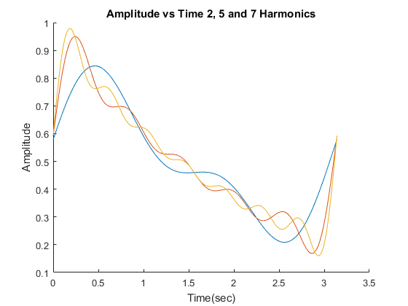

Part B
clc,clear;
% Define variables
t = 0:0.0001:pi;
A0 = 1/2;
w= 0;
n = 1;
count =1;
% Create while loop for the compact fourier equation.
while count ~= n+1
An = (2./(count.*pi)).*sin(count.*pi./2);
Omega = An.*cos(t.*count);
w = w+Omega;
count = count+1;
end
hold on
Endw = 1/2 + w;
plot(t,Endw)
xlabel('time');
ylabel('Amplitude');
title('Amplitude vs Time for Harmonics 1, 3,6,50 and 120');
w = 0;
Endw = 0;
n = 3;
count =1;
while count ~= n+1
An = (2./(count.*pi)).*sin(count.*pi./2);
Omega = An.*cos(t.*count);
w = w+Omega;
count = count+1;
end
hold on
Endw = 1/2 + w;
plot(t,Endw)
w = 0;
Endw = 0;
n = 6;
count =1;
while count ~= n+1
An = (2./(count.*pi)).*sin(count.*pi./2);
Omega = An.*cos(t.*count);
w = w+Omega;
count = count+1;
end
hold on
Endw = 1/2 + w;
plot(t,Endw)
w = 0;
Endw = 0;
n = 20;
count =1;
while count ~= n+1
An = (2./(count.*pi)).*sin(count.*pi./2);
Omega = An.*cos(t.*count);
w = w+Omega;
count = count+1;
end
hold on
Endw = 1/2 + w;
plot(t,Endw)
w = 0;
Endw = 0;
n = 50;
count =1;
while count ~= n+1
An = (2./(count.*pi)).*sin(count.*pi./2);
Omega = An.*cos(t.*count);
w = w+Omega;
count = count+1;
end
hold on
Endw = 1/2 + w;
plot(t,Endw)
w = 0;
Endw = 0;
n = 120;
count =1;
while count ~= n+1
An = (2./(count.*pi)).*sin(count.*pi./2);
Omega = An.*cos(t.*count);
w = w+Omega;
count = count+1;
end
hold on
Endw = 1/2 + w;
plot(t,Endw)
%As the more and more Harmonics are increased the shape of the square wave
%begins to take form.
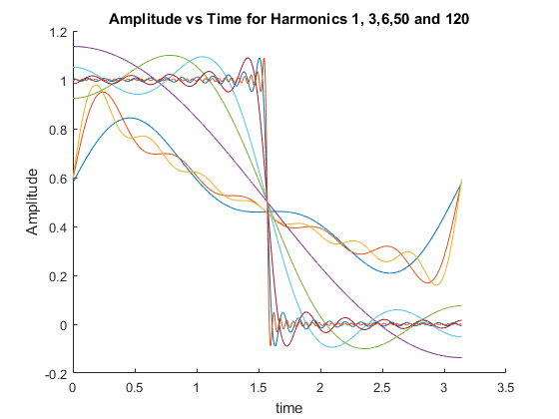
clc,clear
n = 3;
t = 0:1/12000:0.05;
A=1;
w = 2*pi/(1/60);
count = 1;
xx = 0;
End = 0;
% Use the fourier transform equation for the half wave rectified sine.
for count = 1:n;
xx = xx + cos(2*count*w*t) /(4*count^2 -1);
end
End = A/pi + (A/2)*sin(w*t) - (2*A/pi)*xx;
figure
plot(t,End)
xlabel('time');
ylabel('Amplitude');
title('Amplitude vs Time for a 3rd harmonic half wave rectified sine wave');
n = 5;
t = 0:1/12000:0.05;
A=1;
w = 2*pi/(1/60);
count = 1;
xx = 0;
End = 0;
% Use the fourier transform equation for the half wave rectified sine.
for count = 1:n;
xx = xx + cos(2*count*w*t) /(4*count^2 -1);
end
End = A/pi + (A/2)*sin(w*t) - (2*A/pi)*xx;
figure
plot(t,End)
xlabel('time');
ylabel('Amplitude');
title('Amplitude vs Time for a 5th harmonic half wave rectified sine wave');
n = 7;
t = 0:1/12000:0.05;
A=1;
w = 2*pi/(1/60);
count = 1;
xx = 0;
End = 0;
% Use the fourier transform equation for the half wave rectified sine.
for count = 1:n;
xx = xx + cos(2*count*w*t) /(4*count^2 -1);
end
End = A/pi + (A/2)*sin(w*t) - (2*A/pi)*xx;
figure
plot(t,End)
xlabel('time');
ylabel('Amplitude');
title('Amplitude vs Time for a 7th harmonic half wave rectified sine wave');
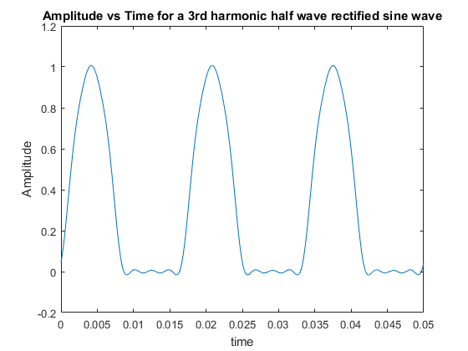
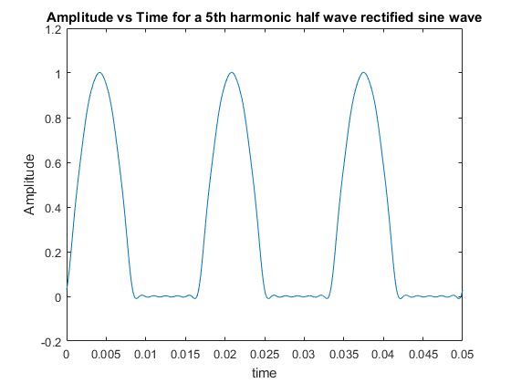
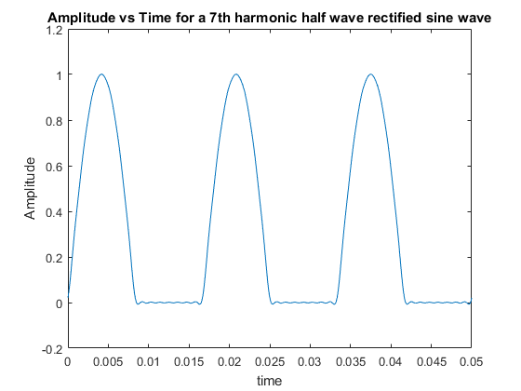

Part 4 Dft/FFt
clc,clear;
Ts=1/64;
T0=4;
N0=T0/Ts;
t=0:Ts:Ts*(N0-1);
t=t';
g=Ts*exp(-2*t);
g(1)=Ts*0.5;
G=fft(g);
[Gp,Gm]=cart2pol(real(G),imag(G));
k=0:N0-1;
k=k';
w=2*pi*k/T0;
subplot(211), stem(w(1:32),Gm(1:32));
subplot(212),stem(w(1:32),Gp(1:32))
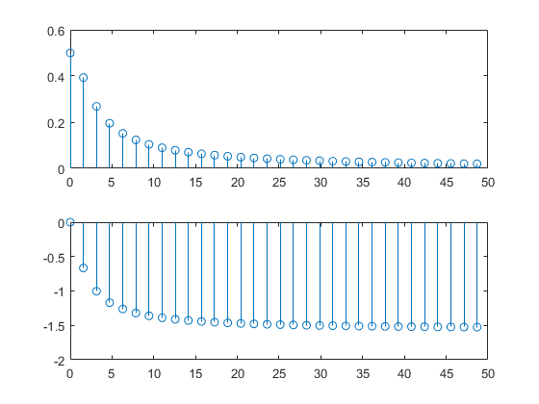

Part 5 FFt
clc,clear
B=4;
f0=1/4;
Ts=1/(2*B);
T0=1/f0;
N0=T0/Ts;
k=0:N0-1;
k=k';
for m =1:length(k)
if k(m)>=0 & k(m)<=3, gk(m)=1; end
if k(m)==4 & k(m)==28 gk(m)=0.5; end
if k(m)>=5 & k(m)<=27, gk(m)=0; end
if k(m)>=29 & k(m)<=31, gk(m)=1; end
end
gk=gk';
Gr=fft(gk);
subplot(211),stem(k,gk)
subplot(212),stem(k,Gr)
Warning: Using only the real component of complex data.
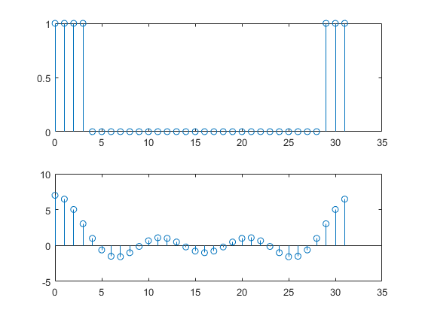

Part 7 Filtering
clc,clear
B=4;
f0=1/4;
Ts=1/(2*B);
T0=1/f0;
N0=T0/Ts;
k=0:N0-1;
k=k';
for m =1:length(k)
if k(m)>=0 & k(m)<=3, gk(m)=1; end
if k(m)==4 & k(m)==28 gk(m)=0.5; end
if k(m)>=5 & k(m)<=27, gk(m)=0; end
if k(m)>=29 & k(m)<=31, gk(m)=1; end
end
gk=gk';
Gr=fft(gk);
subplot(211),stem(k,gk)
subplot(212),stem(k,Gr)
r=0:32; r=r';
for m = 1:length(r)
if r(m) >=0 & r(m)<=7, Hr(m)=1; end
if r(m) >=25 & r(m) <=31, Hr(m) = 1; end
if r(m) >= 9 & r(m) <=23, Hr(m) =0; end
if r(m) ==8 & r(m) == 24, Hr(m) = 0.5; end
end
Hr = Hr';
Yr=Gr.*Hr;
yk = ifft(Yr);
clf, stem(k,yk)
Warning: Using only the real component of complex data.
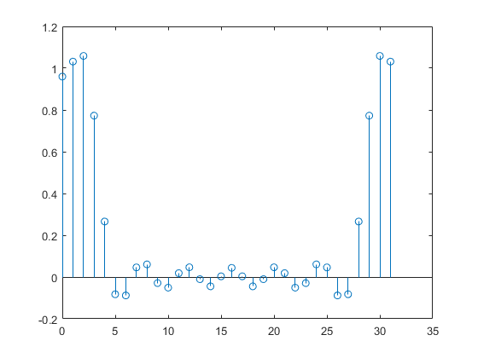
Published with MATLAB® R2016a

Part 6 Simulink
1.
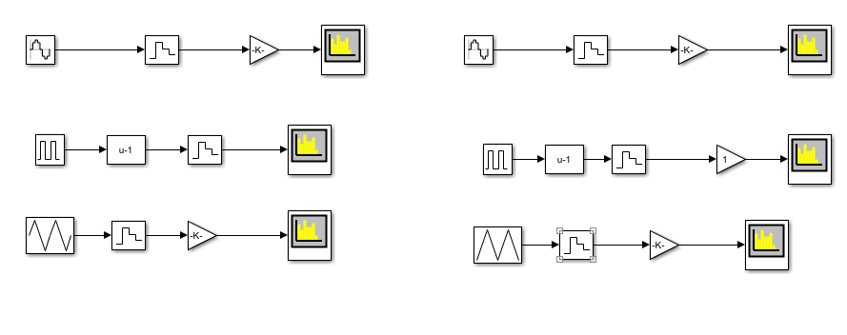
Figure 1: Odd, left side, and even, right side, Simulink for sin, square and triangular wave functions.

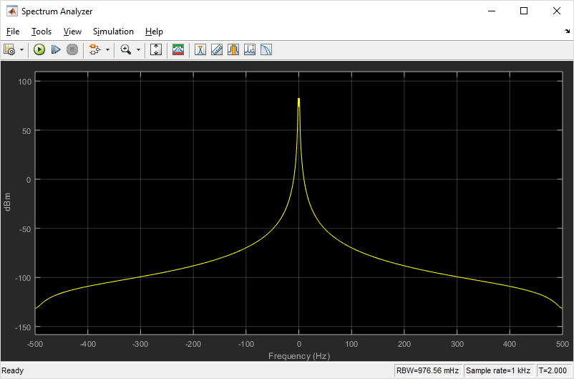
Figure 2: Bandwidth for the Fourier Transform of a sine graph.

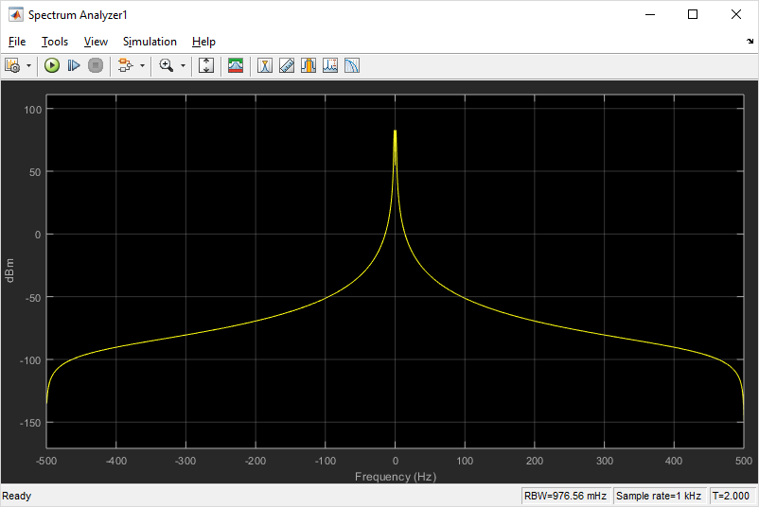
Figure 3: Bandwidth for the Fourier Transform of a Cosine graph.
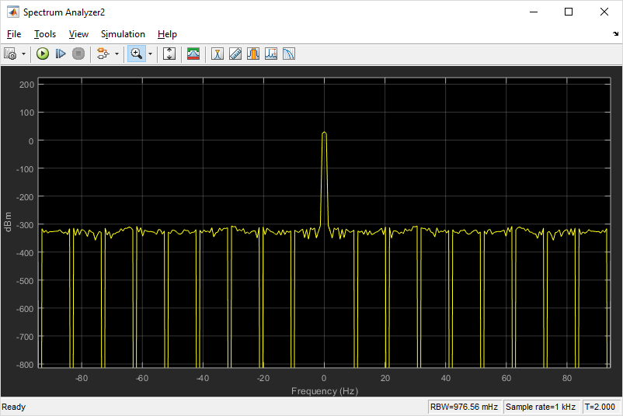
Figure 4: Bandwidth for the Fourier Transform of an odd Square Wave.
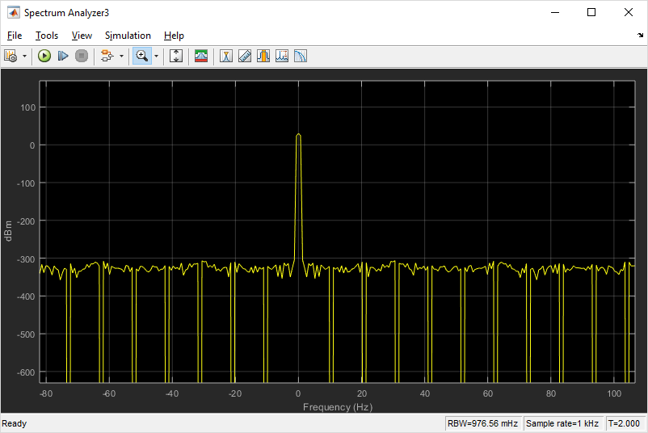
Figure 5: Bandwidth for the Fourier Transform of an Even Square Wave.
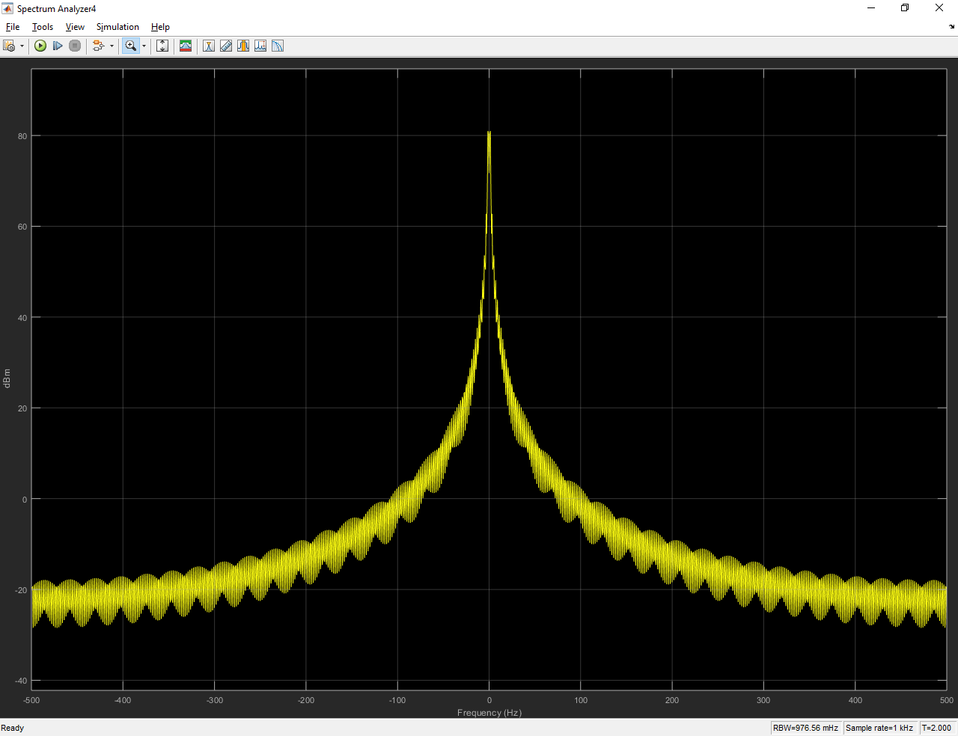
Figure 6: Bandwidth for the Fourier Transform of an odd Triangular Wave.

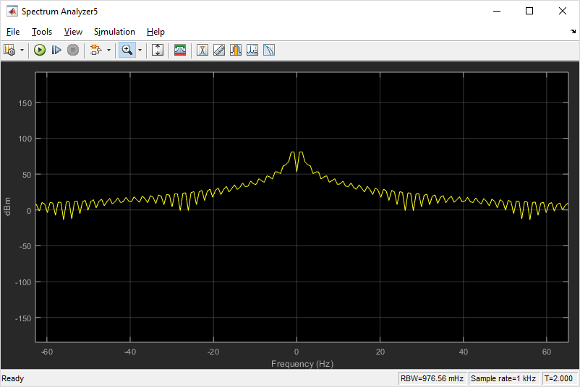
Figure 7: Bandwidth for the Fourier Transform of an even triangular wave.

3:
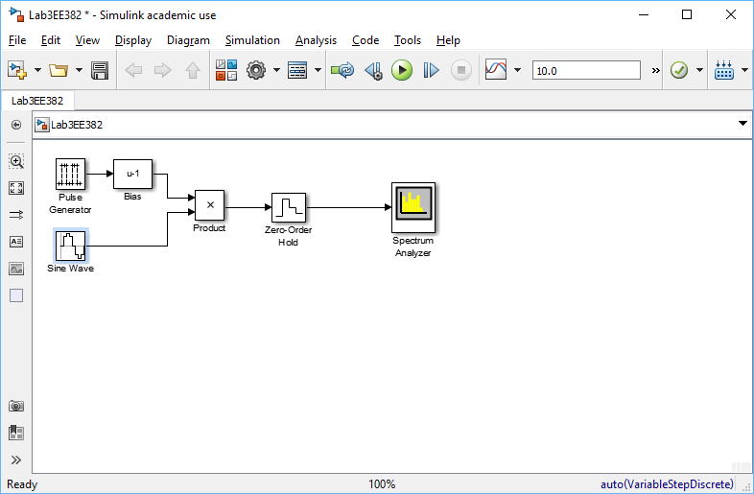
Figure 8: Simulink for Square wave modulation.

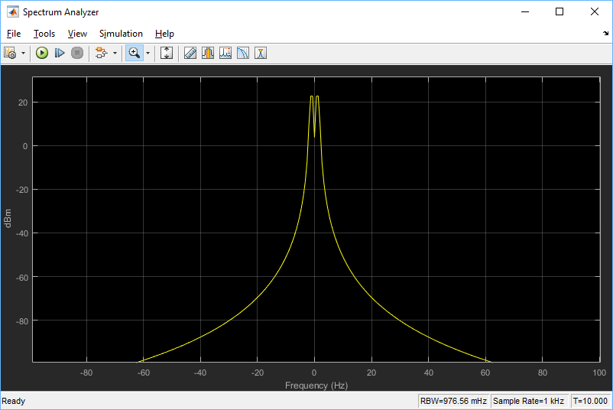
Figure 9: Square wave modulation with a frequency of 1.

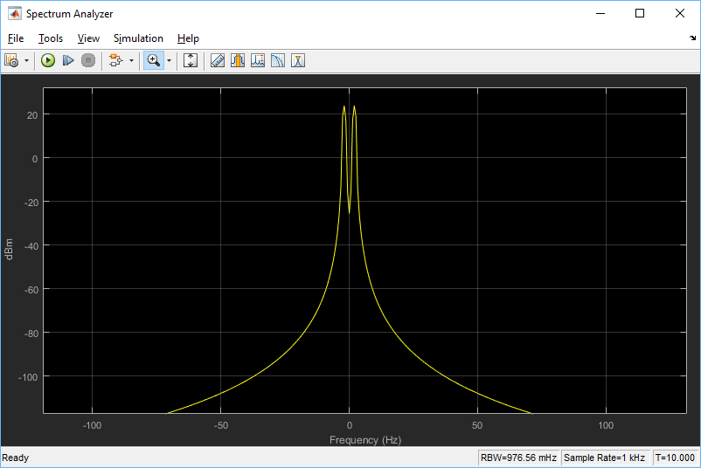
Figure 10: Square wave modulation with a frequency of 2.

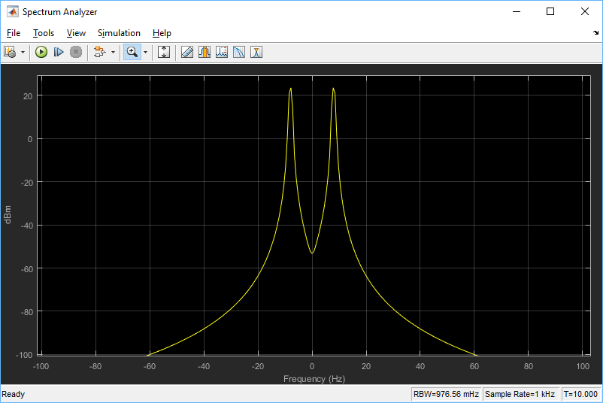
Figure 11: Square wave modulation with a frequency of 8.

